**Assignment sheet for IAM**

Assignment 1 :- Create an IAM user with username of your own wish and grant administrator policy.

**Ans:**

Created an IAM user with name: IAMadmin and granted administrator policy.

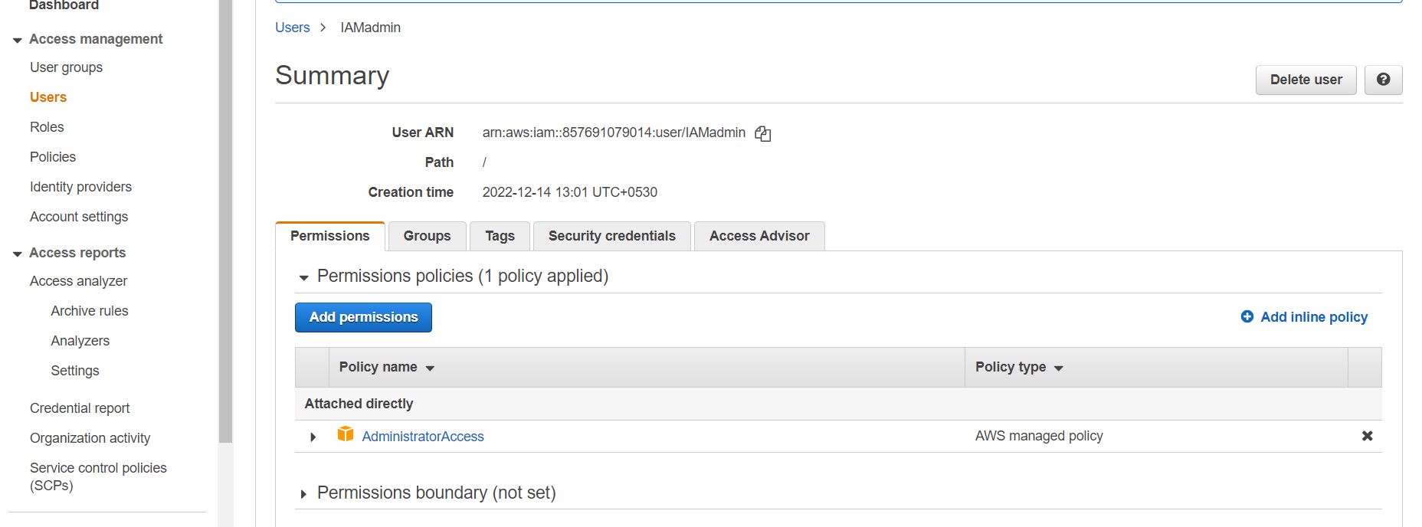

Assignment 2 :- Hello students, in this assignment you need to prepare a

developers team of avengers.

- Create 3 IAM users of avengers and assign them in developer’s groups with

IAM policy.

**Ans:**

Created 3 IAM users IronMan, Thor, Hulk of avengers and assigned them to group named as Developers with IAM full access permission.

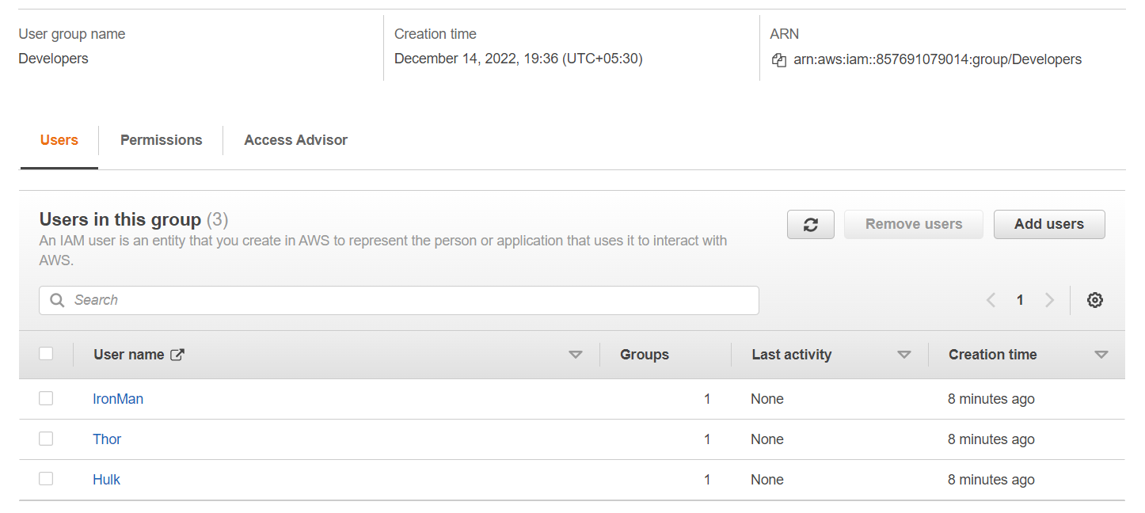

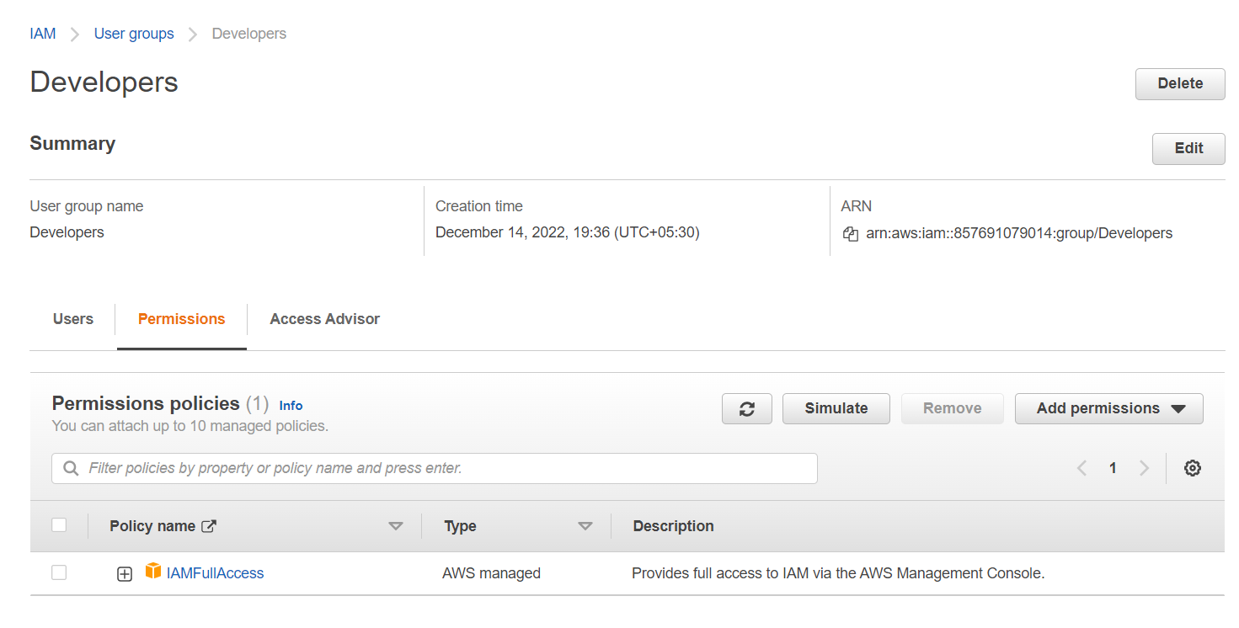

Assignment 3:-

Prepare 15 authentic MCQ questions related to IAM.

**Ans:**

1. True or False : An explicit Deny in IAM precedes over an explicit allow.

A. **True** B. False

2. IAM groups have no credentials of their own.

A. **True** B. False

3. An IAM user can be a member of how many groups maximum?

A. **10 groups**

B. 20 groups

C. 15 groups

D. 5 groups

4. Is there a limit to the number of IAM users in an AWS Account? if so, how many?

A. No Limit

B. 1,000 per region

C. 3,000 per account

**D. 5,000 per account**

E. 5,000 per region

5. Which of the following are features of IAM group

1. Admin groupings of IAM Users
2. **Can hold Identity Permissions**
3. Can be used to login (Access Keys)
4. Can be used to login (Username and password)
5. Can be nested

6 Within AWS policies, what is always a priority?

A. Explicit Allow

**B. Explicit Deny**

C. Depends on the order in the policy

D. No priority

7. What two policies are assigned to an IAM Role

**A. Permissions Policy**

B. Assumption Policy

C. Resource Policy

**D. Trust Policy**

8. Which of the following are true for IAM Roles

A. Roles have associated Long Term Credentials (Access Keys)

**B. Roles can be assumed**

**C. When assumed - temporary credentials are generated**

D. Roles can be logged into

E. When an identity logs into a role - temporary credentials are generated

9. What Three features are provided by AWS Organizations (pick all that apply)

**A. Consolidated billing**

B. Managed assistance for company and AWS account mergers

**C. AWS Account restrictions using SCP**

**D. Account organization via OU's**

E. Protection against credential leaks

F. Company ID reports

10. What functionality is provided by CloudTrail

A. Log Ingestion

B. Metrics management

C. Account Restrictions

**D. Account wide Auditing and API Logging**

11. Is it possible to restrict what the Account Root User can do?

A. Always

B. Never

C. If AWS Organizations are used

**D. If AWS Organizations are used .. but not the management account**

12. What is Role Switching?

A. Changing the permissions on an IAM Role

B. Changing the TRUST on a Role

C. Changing who can assume a Role

D. Logging into a Role

E. **Assuming a role in another AWS account to access that account via the console UI**

13. What are valid IAM Policy types (choose all that apply)

**A. AWS Managed Policy**

**B. Customer Managed Policy**

C. Self-Managed Policy

**D. Inline Policies**

E. External Policies

14. Which of the following is not a component of IAM?  
  
A. Roles  
B. Users  
**C. Organizational Units**  
D. Groups

15. Which of the following is not a feature of IAM?  
  
A. **IAM allows you to setup biometric authentication, so that no passwords are required.**  
  
B. IAM offers fine-grained access control to AWS resources.

C. IAM offers centralized control of your AWS account.  
  
D. IAM integrates with existing active directory account allowing single sign-on.

Assignment 4:- Launch your linux instance in IAM and update your machine.

**Ans:**

Launched Linux in IAM and updated the machine.

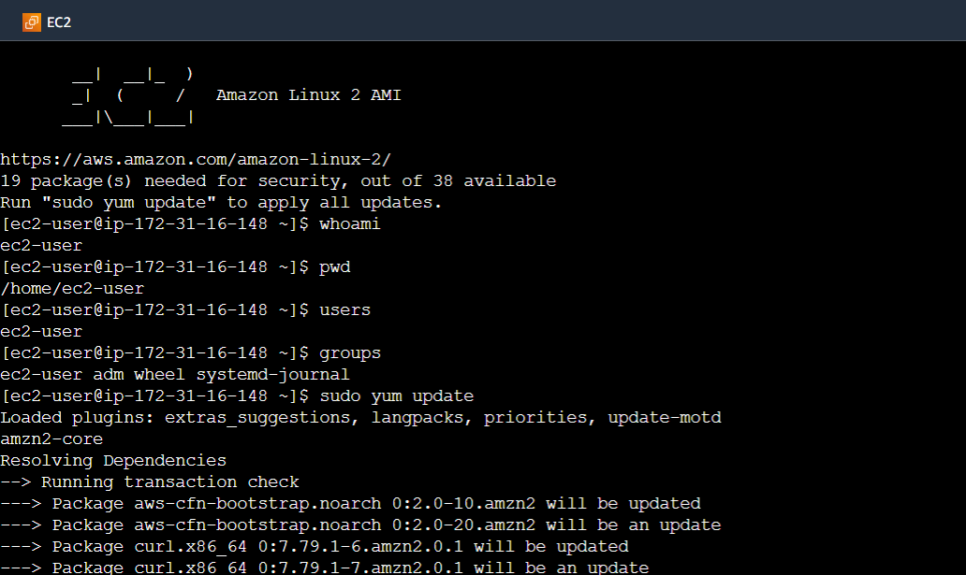

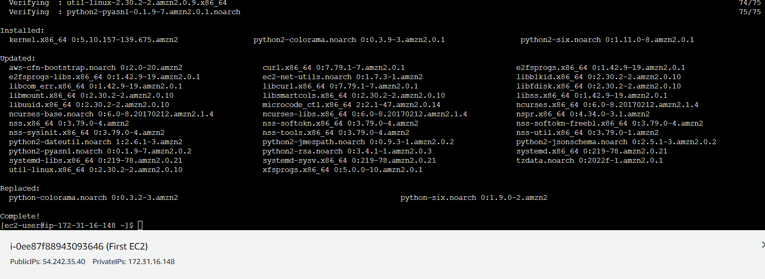

Assignment 3:-

Define a condition in policy for expiration like "DateGreaterThan":{"aws:CurrentTime":"2020-04-01T00:00:00Z"},

"DateLessThan":{"aws:CurrentTime":"2020-06-30T23:59:59Z"}

Define the span of 4 months as per your wish.

**Ans:**

This example shows how to create an identity-based policy that allows access to actions based on date and time. This policy restricts access to actions that occur between Feb 1, 2020 and June 01, 2020 (UTC), inclusive. This policy grants the permissions necessary to complete this action programmatically from the AWS API or AWS CLI.

